Entrainment nights had no difference in predicted arousal rates relative to non-entrainment nights
We calculated arousal rate as the predicted number of arousals per minute of entrainment delivery. Entrainment nights had event markers for real arousals, whereas non-entrainment nights did not. We simulated arousal events on non-entrainment nights and then used the predicted arousal rates across all nights. We validated the simulation against real arousal events on entrainment nights (Figure 1). Real and predicted arousal rates were identical (real arousal rate = 0.761 + 0.068 arousals/min (n=743); predicted arousal rate= 0.761 + 0.068 arousals/min (n=743)). We used a linear model (arousal rate ~ real_or_predicted + stimType + (1|Subject) + (1|night)) and found that there was no statistically significant difference between real and predicted arousal rates [F(1, 1483) = 0.782, p = 0.373]. Therefore, we use the predicted arousal rate as our metric across all conditions, allowing us to compare the sham condition as well. Additionally, our model confirmed no difference in arousal rate between auditory and haptic stimulation [F(1,1483) = 0.707, p = 0.707].
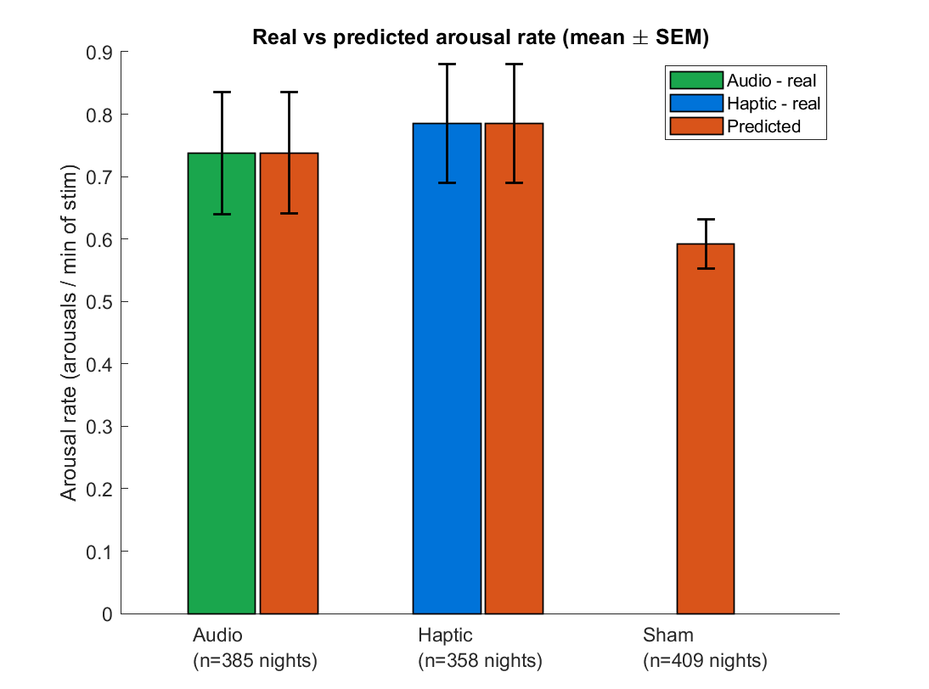
Figure 1. Validation of predicted arousal rates against real arousal events on entrainment nights.
Next, we evaluated whether our entrainment procedure mitigated arousals at night. If our SWE intervention is able to support sleep quality and next-day cognition and mood, then one potential avenue is through protecting against arousals. To check this hypothesis, we compared the predicted arousal rate between entrainment and non-entrainment nights (Figure 2). We fit a linear mixed-effects model with entrainment condition as a fixed effect and participant as a random effect. (predicted arousal rate ~ entrainment condition + (1 | participant)). The analysis included 743 entrainment files and 409 non-entrainment files. Contrary to our hypothesis, arousal rate was not significantly different on entrainment nights compared to non-entrainment nights (entrainment: M = 0.798 ± 0.03 arousals/min; non-entrainment: M = 0.592 ± 0.04 arousals/min) [F(1,1172) = 3.586, p = 0.059]. Thus, our hypothesis was not supported by our findings. There is a trend in the opposite direction, which suggests that presentation of sensory cues during slow-wave sleep could induce a greater number of arousals than the sham cues, but this pattern is not statistically significant.
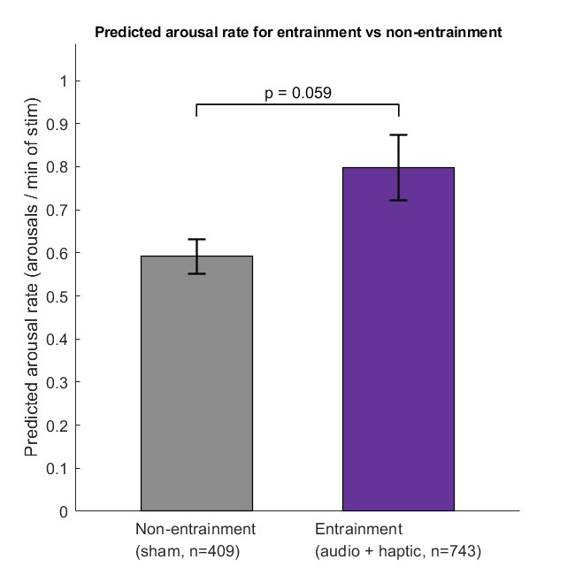
Figure 2. Comparison of arousal rate between entrainment nights and non-entrainment nights.
H13: Improvements in the behavioral measures will correlate with the arousal rate(defined by the number of large body movements and transitions out of detected N3 sleep); a higher arousal rate will be linked to better outcomes.
Behavior outcome ~ entrainment_type * predicted_arousal_rate + (1|userID)
SWE Arousals next steps
- For FDR, one family is 7 (only interaction term)
- Use predicted arousals for the interaction term

